Государственное учреждение образования «Великолетчанский детский дом»
State Institution of Education «Velikoletchanskiy Orphanage»
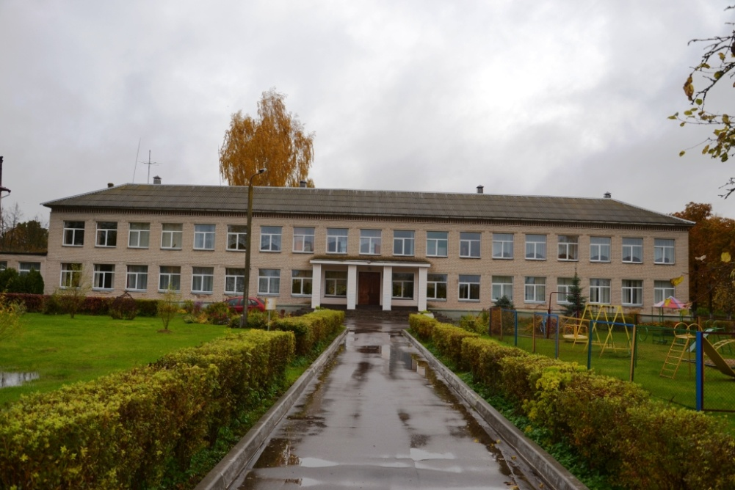
А brief description of

It is located at the address: Vitebsk region Bolshie Letcyi village, Sovetskaya str., 8a

Complex of capital structures: a total area of ​​4202.40 square meters, built in 1961
1. The main complex - educational building (building number 1), dormitory (building number 2).
2. Economic complex - carpentry shop, garages, laundry, bath, medical unit, greenhouse, TP building.

Main building and sleeping building:
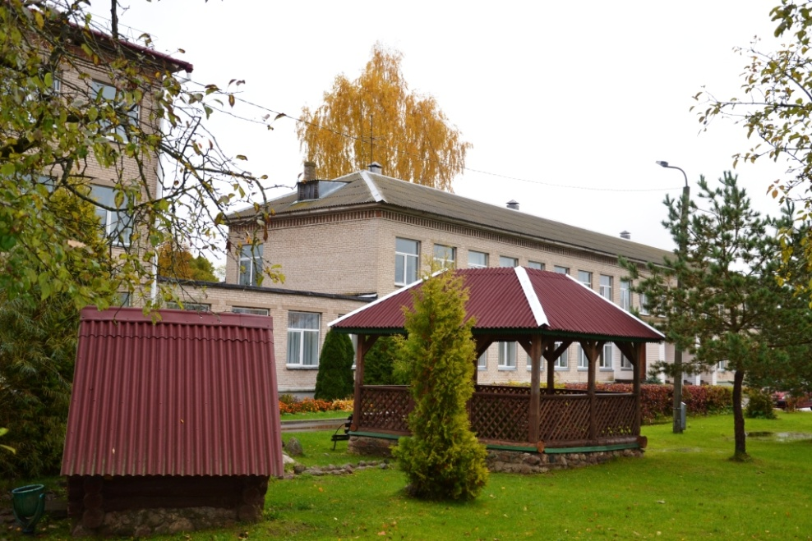
Buildings specialized for the education, upbringing and living of children, there is a roadway, a pedestrian precinct. Two-story brick building, the foundation - reinforced concrete blocks, floors - reinforced concrete slabs, slate roof, interior decoration - painting, communications (heating, water, sewage, telephone, electricity), ventilation ducts, assembly hall.

The complex of capital buildings can be used for living and raising children, a hotel complex, a health camp, a social services center with a boarding house for the elderly, a sports and health complex, etc.
There is an accomplishment of the territory: a fence, two playgrounds, a stadium, gazebos, an orchard, a garden.
General characteristics of the site

On the building there are title documents for the maintenance of the territory allocated land area of 3.425,7 hectares.
The land plot is in state ownership (the Republic of Belarus), is provided for the implementation of the investment project, for use or lease.
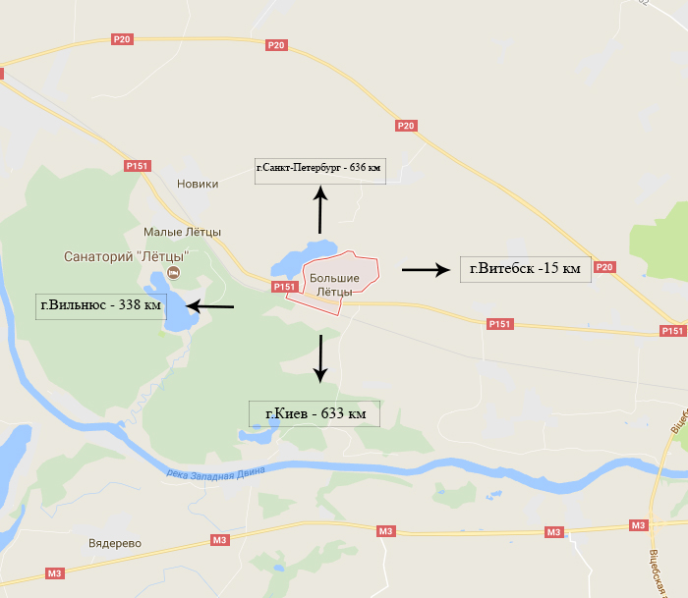
Transport connection

The land is located 0.3 km from the Letchanskoe Lake.
The buildings are located on the national road P-151, 9 km from the regional center of Vitebsk and 38 km from the Vitebsk branch of RUE "Belaeronavigatsia" (Airport "Vitebsk"); 3 km from the sanatorium Malye Letcy; in 15 km from the railway station "Vitebsk Passenger", there are access roads.
Infrastructure

Power supply networks are located 40 m from the land plot, total power 320 KW/h. Water from a well in the village (6 m3 / h). There is a technical opportunity for gasification of the land plot from the gas pipeline of high-pressure natural gas of the 2nd category (450 m to the gas pipeline), the medium pressure gas pipeline is located 100 m from the site.

Fertility of soils

The soil is mainly podzolic loams on loesslike rocks. In addition to the predominant sod-podzolic soils, sod-podzolic swampy and sod-swampy soils are encountered.

Sights
An ancient settlement of the Dnieper-Dvina culture, source, a mound on the shore of Lake Letchanskoe. A section of the road paved with cobblestone ("Catherine's tract" the second half of the XVIII ct.). Remains of the garden and park ensemble, botanical garden and manor house of botanist Vladimir Adamov (second half of the XIX ct.). Oak-giant (about 280-300 years old).

