Государственное учреждение образования «Летчанская баловая школа Витебского района»
State Institution of Education «Letchanskaya Basic School Vitebsk Region»
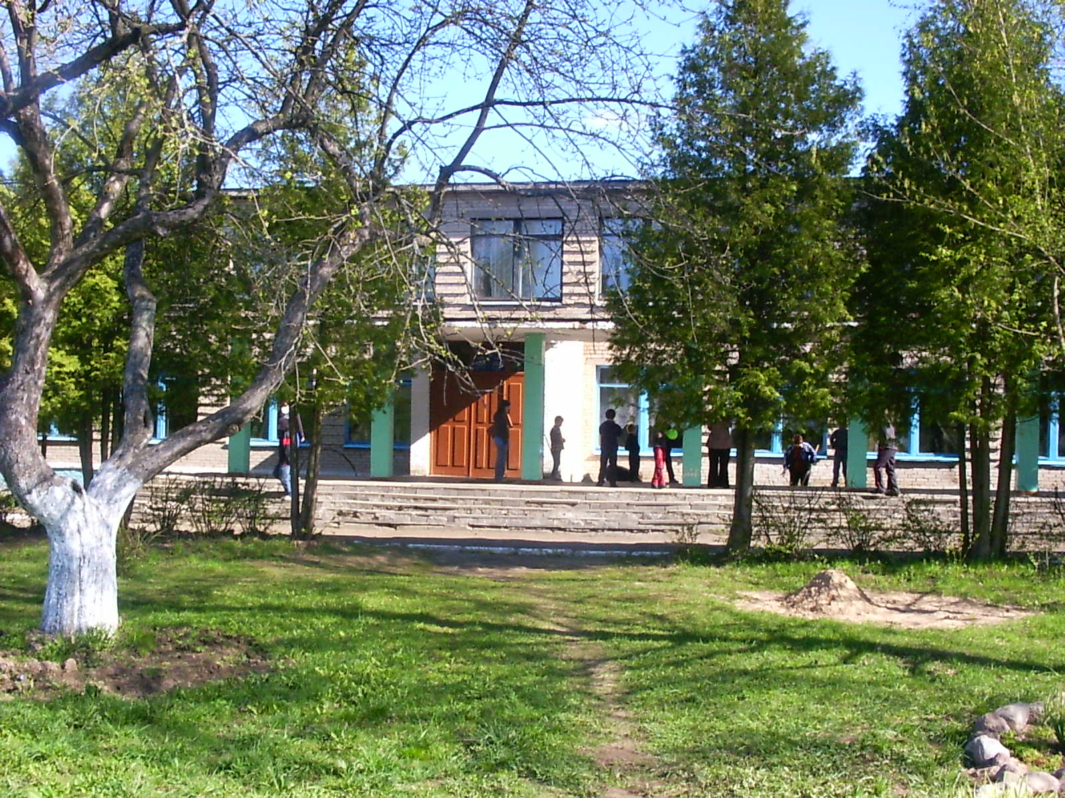
А brief description of

It is located at the address: Vitebsk region Bolshie Letcyi village, Shkolnaya str., 40a

A complex of capital structures with a total area of 1,742 sq. m., Built in 1970
1. The main complex is the educational building (building No. 1).
2. Economic complex-a shed, a vegetable storehouse, a greenhouse.

Main building:
The buildings are specialized for the education and upbringing of children, there is a roadway, a pedestrian section. A two-storey brick building, the foundation is reinforced concrete blocks, the floors are reinforced concrete slabs, the roof is soft (made of surfacing material), the interior is painted, communications (heating, water, sewerage, telephone, electricity) are provided, ventilation ducts and a gym are available.
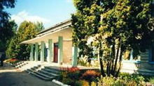
The complex of capital buildings can be used for living and bringing up children, a hostel, a hotel complex, a health camp, a social services center with a boarding house for the elderly, a sports and health complex, etc.
There is an accomplishment of the territory: a fence, a playground, a stadium, flower beds, an orchard.

General characteristics of the site

On the building there are title documents for the maintenance of the territory allocated land area of 2.578 hectares.
The land plot is in state ownership (the Republic of Belarus), is provided for the implementation of the investment project, for use or lease.
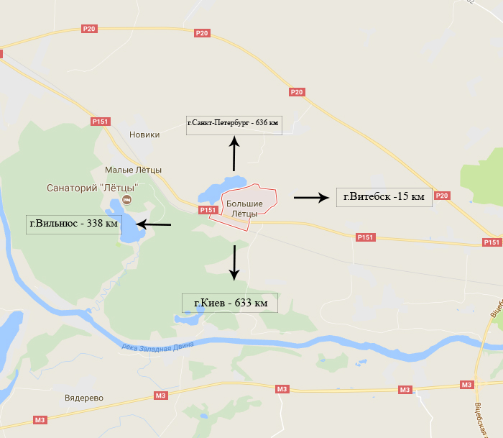
Transport connection

The land is located 0.3 km from the Letchanskoe Lake.
The buildings are located on the national road P-151, 9 km from the regional center of Vitebsk and 38 km from the Vitebsk branch of RUE "Belaeronavigatsia" (Airport "Vitebsk"); 3 km from the sanatorium Malye Letcy; in 15 km from the railway station "Vitebsk Passenger", there are access roads.
Infrastructure

Power supply networks are located 50 m from the land plot, total power 320 KW/h. Water from a well in the village (6 m3 / h). There is a technical opportunity for gasification of the land plot from the gas pipeline of high-pressure natural gas of the 2nd category (850 m to the gas pipeline), the medium pressure gas pipeline is located 80 m from the site.

Fertility of soils

The soil is mainly podzolic loams on loesslike rocks. In addition to the predominant sod-podzolic soils, sod-podzolic swampy and sod-swampy soils are encountered.

Sights
An ancient settlement of the Dnieper-Dvina culture, source, a mound on the shore of Lake Letchanskoe. A section of the road paved with cobblestone ("Catherine's tract" the second half of the XVIII ct.). Remains of the garden and park ensemble, botanical garden and manor house of botanist Vladimir Adamov (second half of the XIX ct.). Oak-giant (about 280-300 years old).

